Configure Shibboleth as a SAML Service Provider (Proxy for a Legacy Application) in IIS Server

Purpose: Shibboleth can be used as an Identity Provider (IdP) which is similar to Keycloak. But for a legacy web application that does not have the capability to process SAML Single Sign-On (SSO) directly, Shibboleth can be used as a SAML Service Provider (SP) that acts as an authentication layer in front of the application, handling the SAML SSO process on its behalf.

1. Enable IIS Server in Windows OS
If IIS server is not enabled in Windows OS, we need to enable IIS server first because configuring Shibboleth as a SP depends on IIS server or Apache Web Server.
Press Windows icon key and R key (Win + R) to bring the Run command window.
Put “optionalfeatures” then click OK:
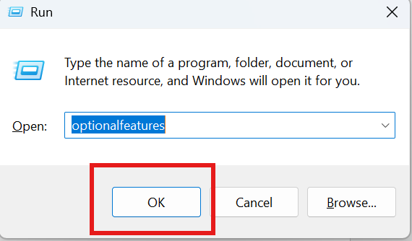

Select Internet Information Services and related components and features:
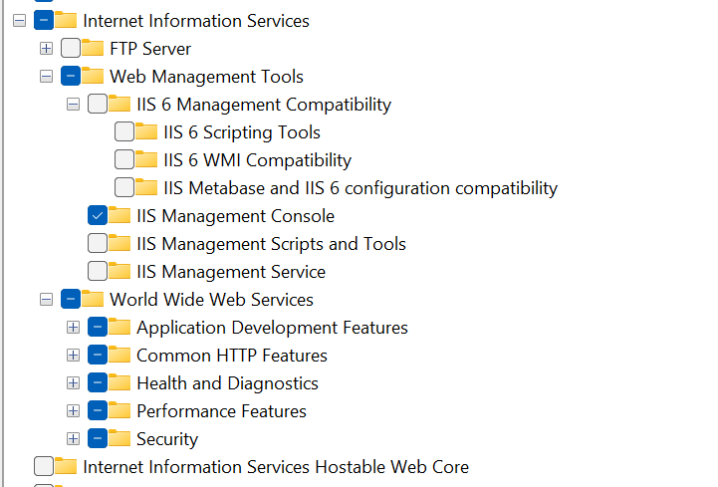

2. Install URL Rewrite and Application Request Routing (ARR)
If your IIS server does not have URL Rewrite and Application Request Routing components, you need to download and install them.
URL Rewrite: https://www.iis.net/downloads/microsoft/url-rewrite
Application Request Routing: https://www.iis.net/downloads/microsoft/application-request-routing


3. Install Shibboleth SP
Shibboleth can be used as an IdP or SP, but they are not the same software packages. To install Shibboleth SP that will be integrated with IIS server, we need to download and install the software installer with .msi file extension. It can be downloaded at: https://shibboleth.net/downloads/service-provider/latest/win64/
Follow the steps to install Shibboleth SP:
Click shibboleth-sp-3.6.0.0-win64.msi then click Next:
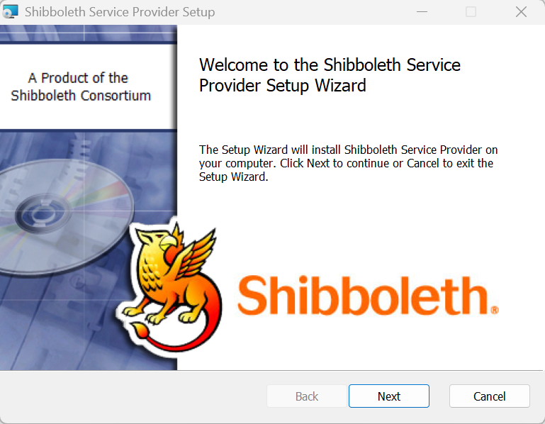
Accept terms and click Next:
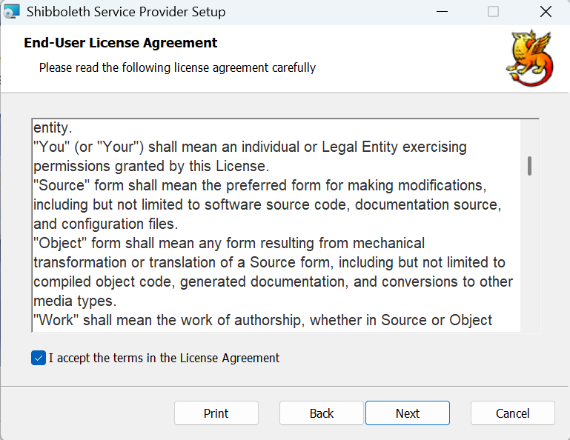
Specify installation location and check Configure IIS support and click Next:
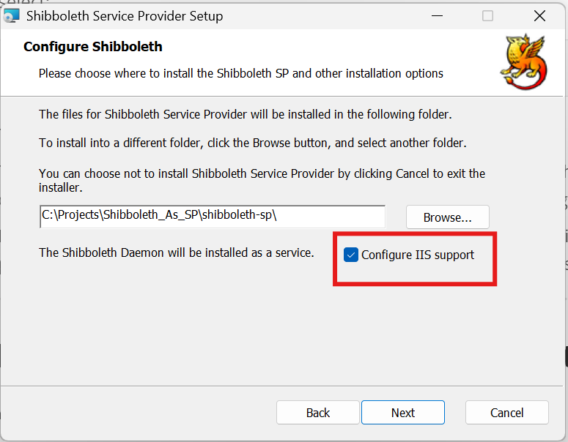
Click Install:
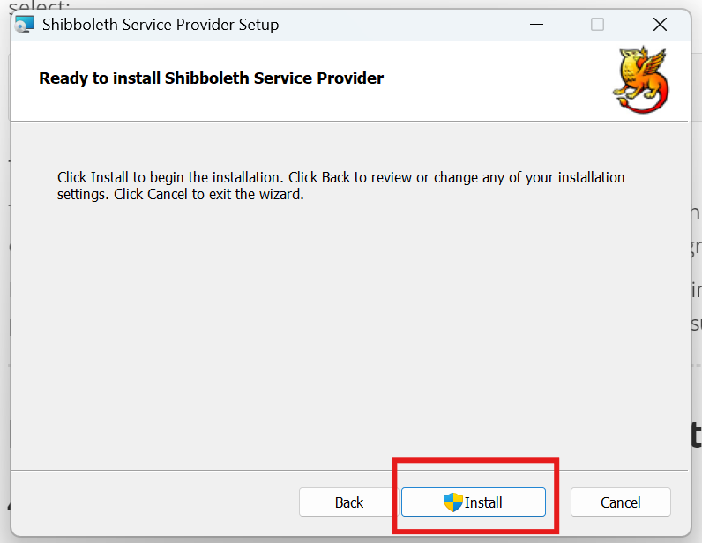
Click Finish:
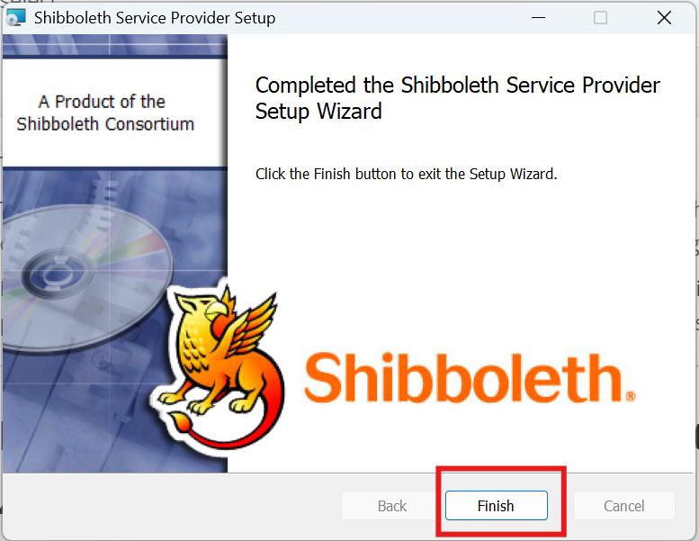
Click Yes to restart your computer:
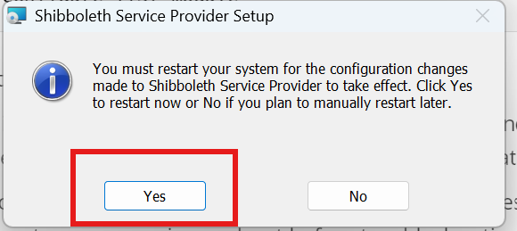

4. Check the Shibboleth SP Windows Service
Press Windows icon key and R key (Win + R) to bring the Run command window.
Type: services.msc
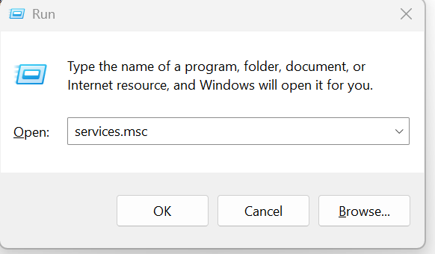

You should see all the services and Shibboleth Daemon service is running, and you can start or stop Shibboleth service there.
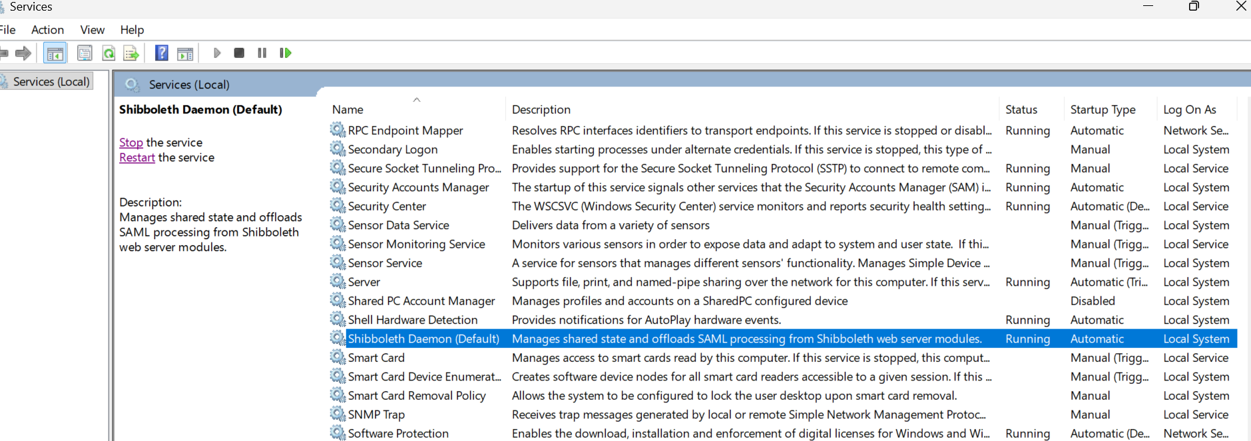

5. Create an IIS Site
Use Win + R and type “inetmgr” to open IIS manager.
Right click Sites and select Add Website:
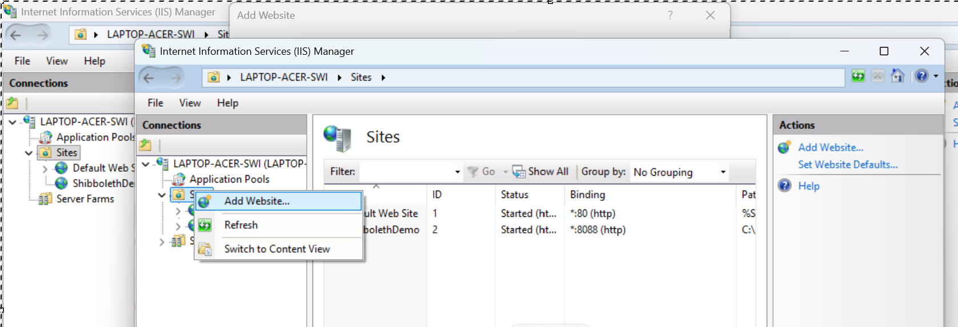

Enter Site name (ShibbolethDemo), Physical path, and Binding information and click OK:
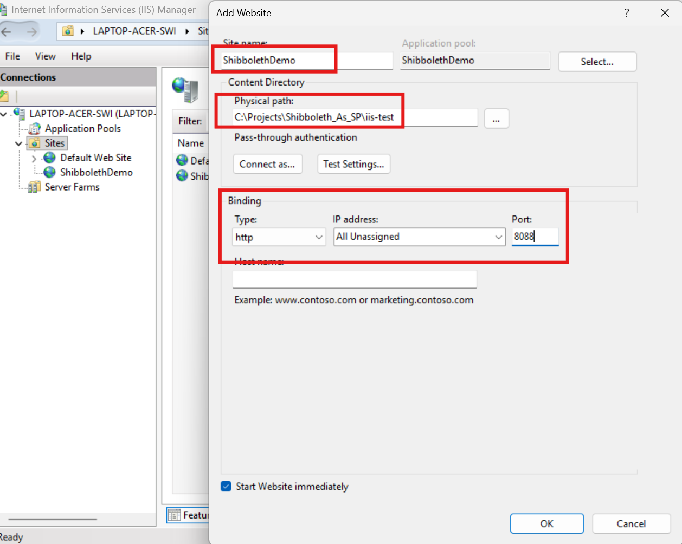
You may add an index.html file under C:\Projects\Shibboleth_As_SP\iis-test and then type the URL in a browser to test if the site is up and running: http://localhost:8088
This is a temporary site created as the place holder for Shibboleth SP service. We will use URL Rewrite and Application Request Routing components in IIS server to map the Shibboleth SP to this URL later.

6. Configure Keycloak Metadata for Shibboleth SP
We will use Keycloak as the IdP and Shibboleth as the SP.
Start Keycloak server (run start-keycloak.bat or start-keycloak-ssl.bat) and access the Keycloak metadata URL: https://localhost:9991/realms/MySecurityRealm/protocol/saml/descriptor
Download/save that XML as C:\Projects\Shibboleth_As_SP\shibboleth-sp\etc\shibboleth\keycloak-metadata.xml.
To make Shibboleth be aware of Keycloak IdP, open C:\Projects\Shibboleth_As_SP\shibboleth-sp\etc\shibboleth\shibboleth2.xml and add:
<MetadataProvider
type="XML"
path="keycloak-metadata.xml"/>
Important Note: Backup the original shibboleth2.xml first.

7. Configure Shibboleth SP Identity
In shibboleth2.xml, modify ApplicationDefaults to specify Shibboleth SP identity:
<ApplicationDefaults
entityID="http://localhost:8088/shibboleth"
REMOTE_USER="uid">

The SP Entity ID therefore is http://localhost:8088/shibboleth.

8. Configure Shibboleth SSO
The IdP entity ID (KeyCloak) should be specified for SSO.
In shibboleth2.xml, inside <Sessions> configure Keycloak:
<SSO entityID="https://localhost:9991/realms/MySecurityRealm">
SAML2
</SSO>
Note: https://localhost:9991/realms/MySecurityRealm is the IdP (Keycloak) entity ID. It is different from the SAML protocol endpoint, https://localhost:9991/realms/MySecurityRealm/protocol/saml.
We temporarily disable SSL for testing only:
<Sessions
lifetime="28800"
timeout="3600"
relayState="ss:mem"
checkAddress="false"
handlerSSL="false">

9. Wrap IIS Site in Shibboleth SP Session
We want to wrap the IIS site access in Shibboleth SP session to force every access to the IIS site needs SAML authentication unless the authenticated Shibboleth SP session already exists, so we configure the RequestMapper so requests to port 8088 require a Shibboleth session.
In shibboleth2.xml, add:
<RequestMapper type="Native">
<RequestMap>
<Host
name="localhost"
scheme="http"
port="8088"
authType="shibboleth"
requireSession="true"/>
</RequestMap>
</RequestMapper>
10. Configure IIS Site ID in Shibboleth
In shibboleth2.xml, find <ISAPI>, then configure the IIS site:
<ISAPI
normalizeRequest="true"
safeHeaderNames="true"
useVariables="true"
useHeaders="true">
<Site
id="2"
name="localhost"
scheme="http"
port="8088"/>
</ISAPI>
Note: The id must exactly match the actual IIS Site ID:
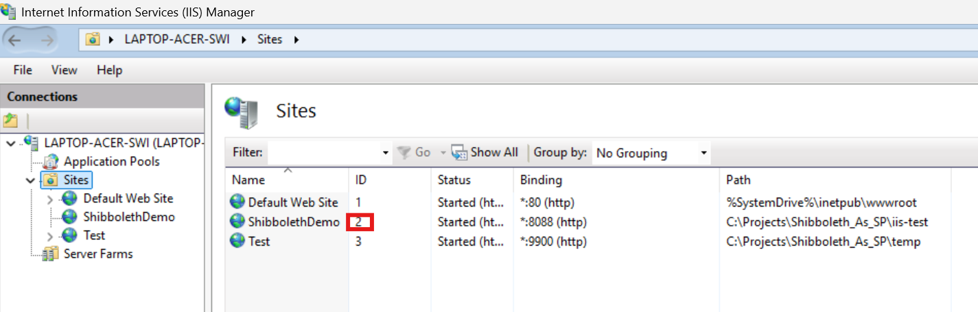

11. Configure Keycloak SAML Client
Assumption: a security realm, MySecurityRealm, has been created, and there are users that have been created under this security realm.
Create a new client under the security realm MySecurityRealm. The client corresponds to the Shibboleth SP we created before.
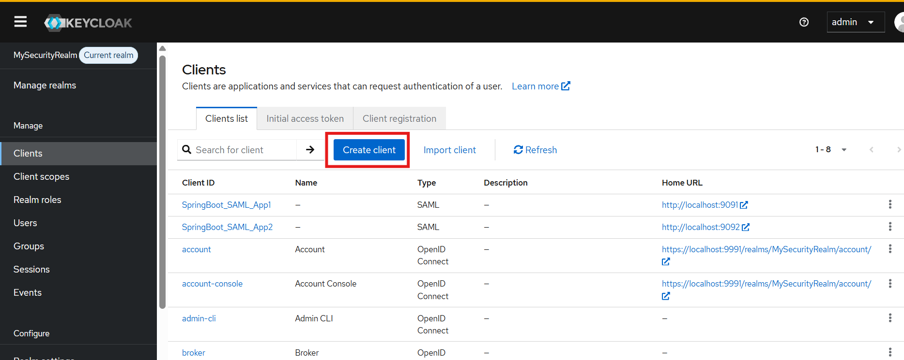

Fill the form using the following values:
Client type: SAML
Client ID: http://localhost:8088/shibboleth
Note: The Client ID must correspond to the Shibboleth SP entityID.
Then click Next
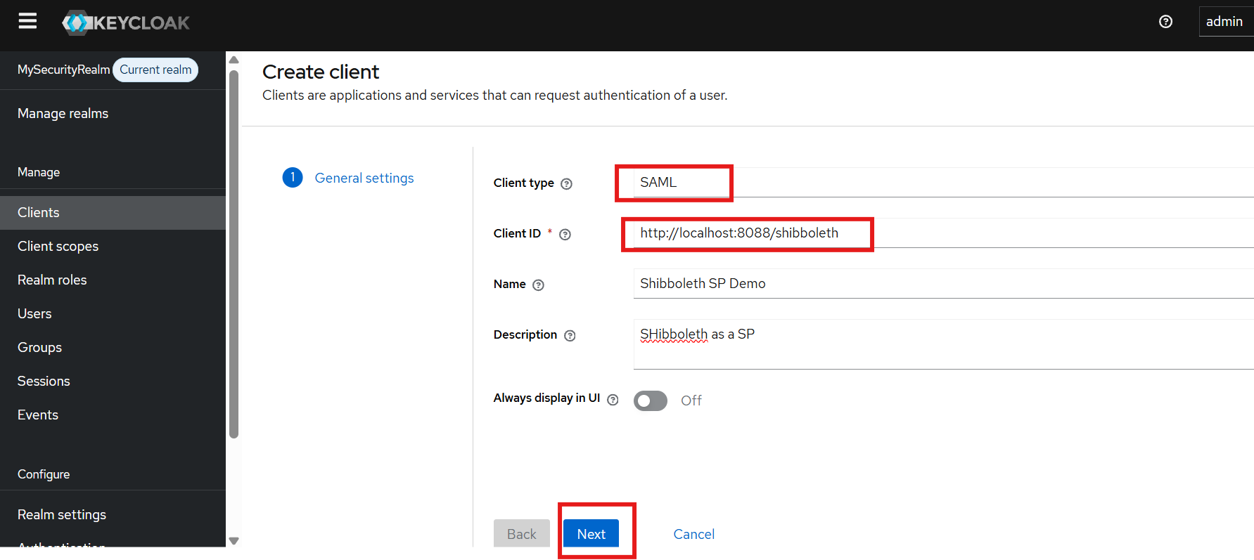

Valid redirect URIs: http://localhost:8088/Shibboleth.sso/SAML2/POST
Master SAML Processing URL: http://localhost:8088/Shibboleth.sso/SAML2/POST

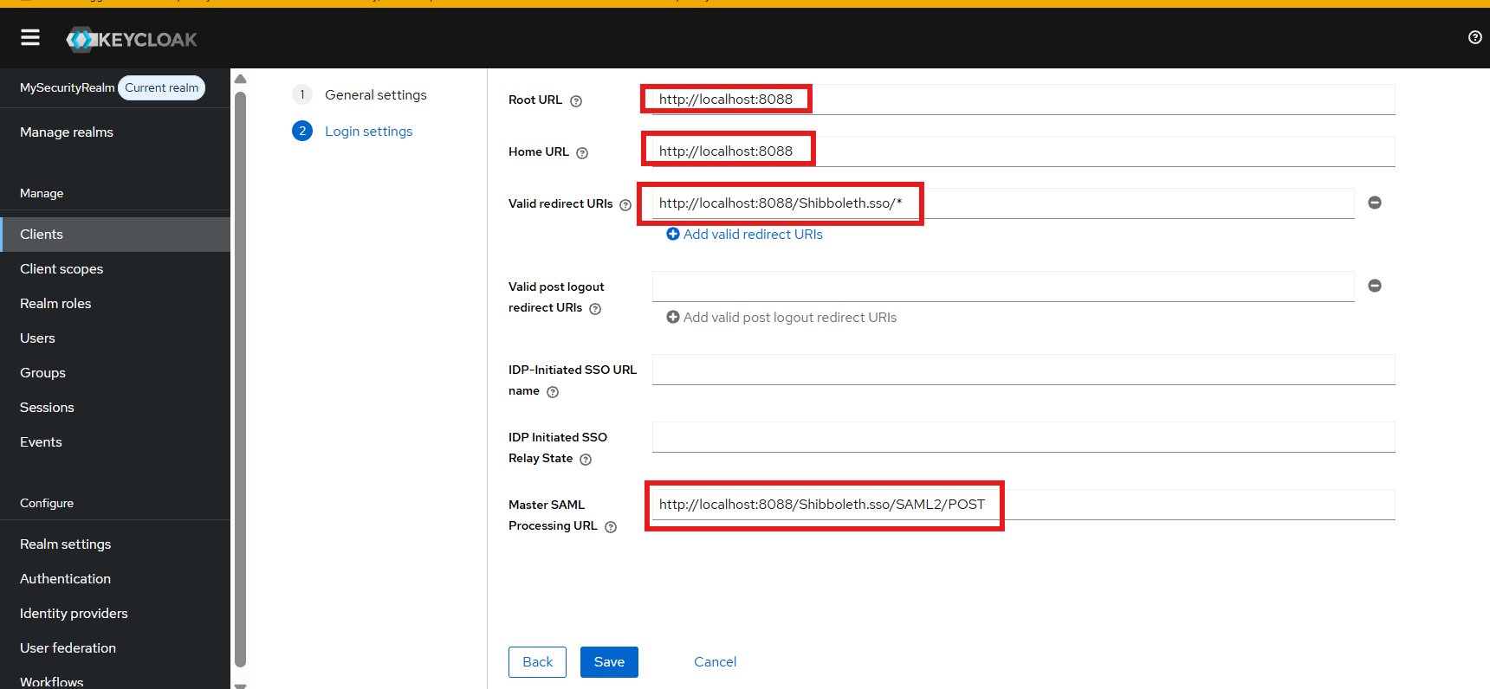

Disable signature temporarily by clicking Keys, then turn off Client signature required:
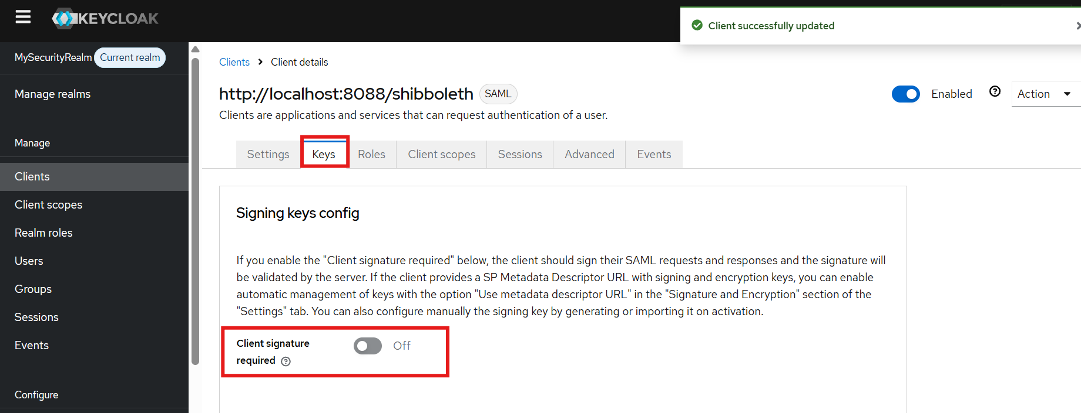

11. Create the Keycloak “uid” Mapper
We want to pass the username value in Keycloak as the “uid” SAML attribute to Shibboleth SP after successful SAML authentication so that application can access the “uid” value.
Click the Clients list then click the Shibboleth SP client:
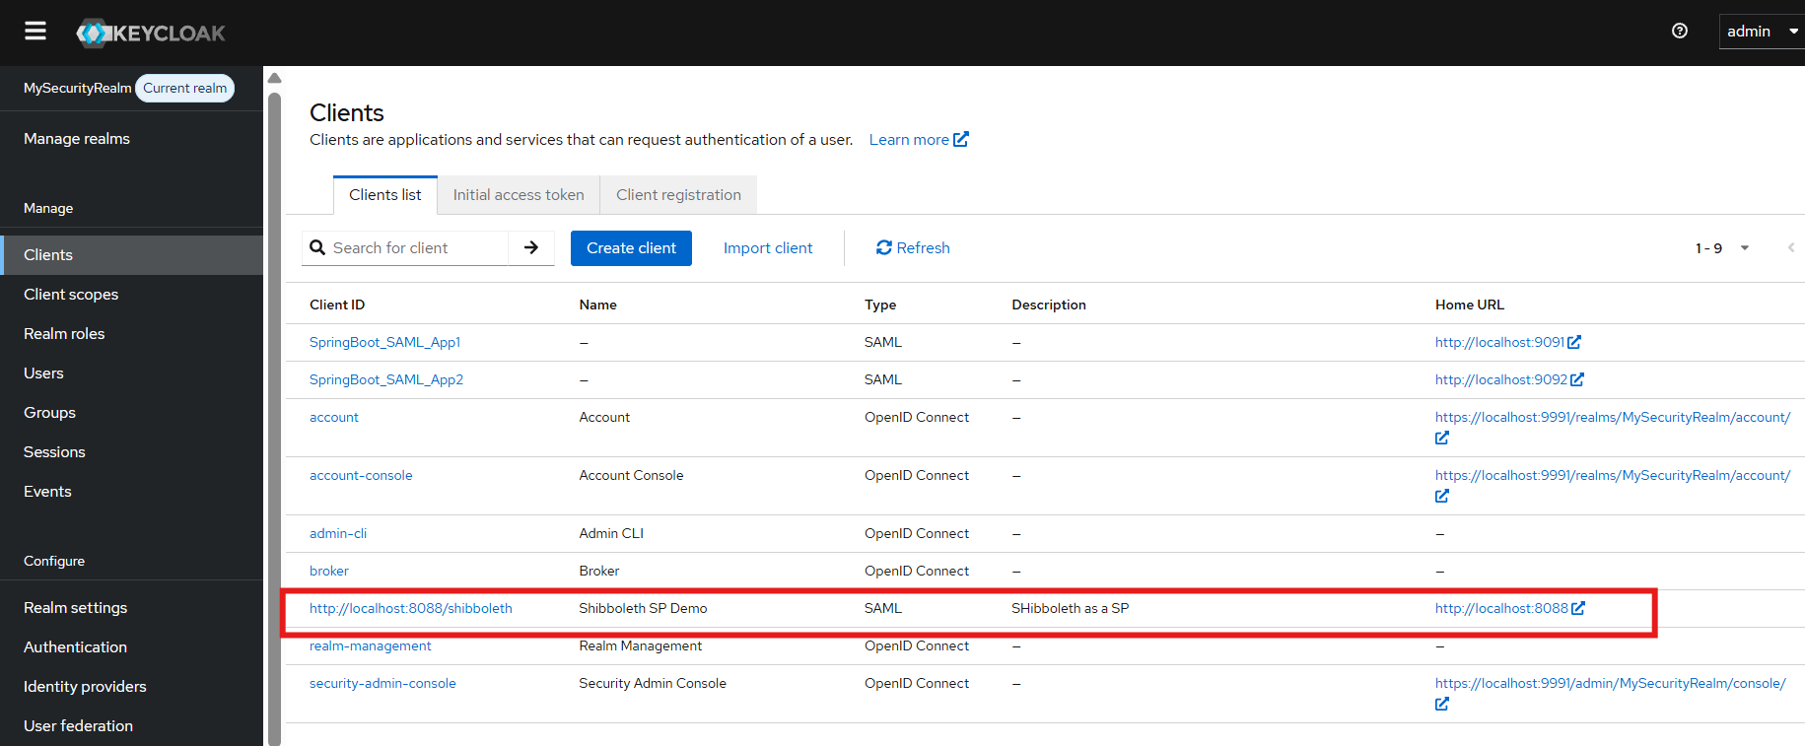

In Client scopes, click dedicated scope (http://localhost:8088/shibboleth-dedicated):
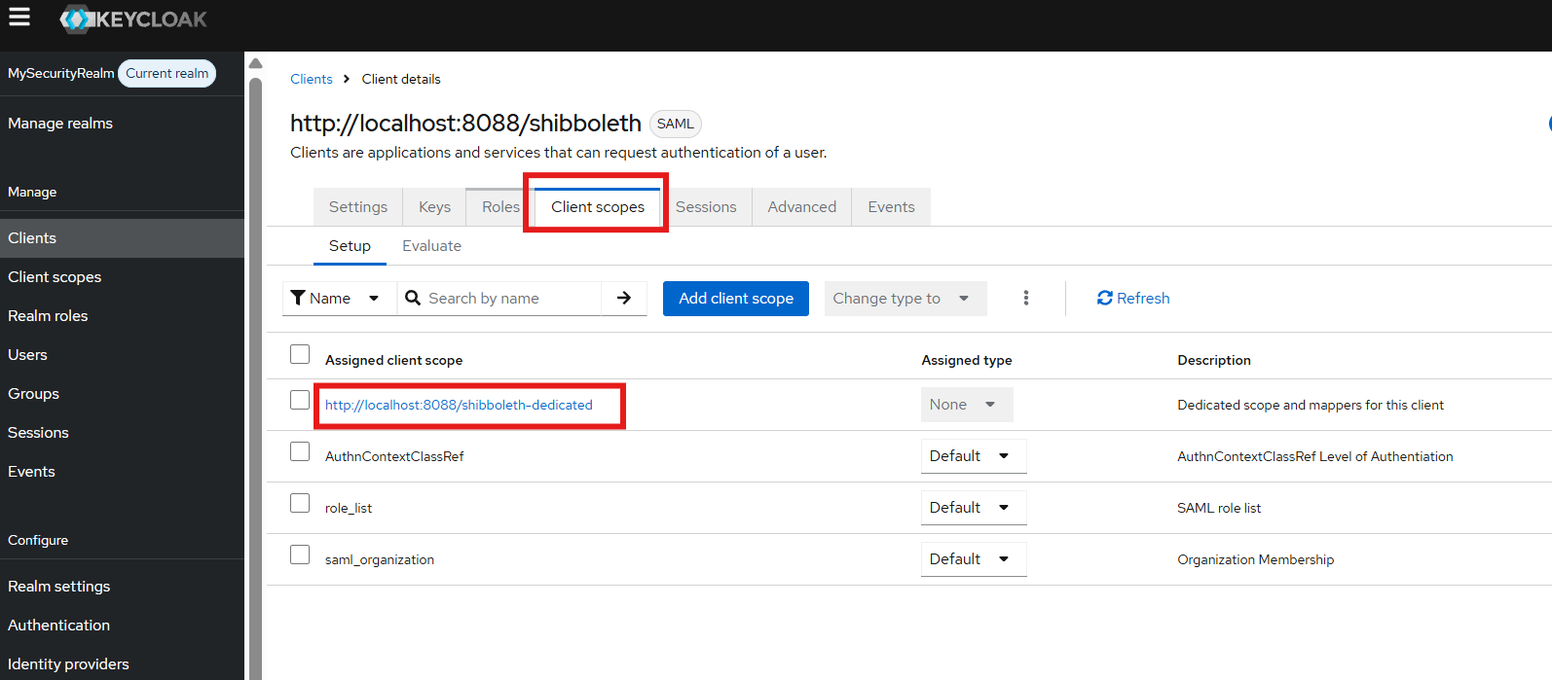

Add a new attribute mapper by clicking Configure a new mapper:
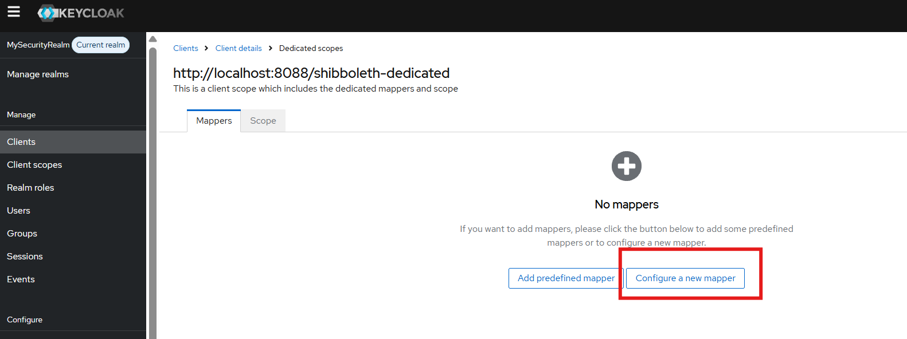

Click User Property:
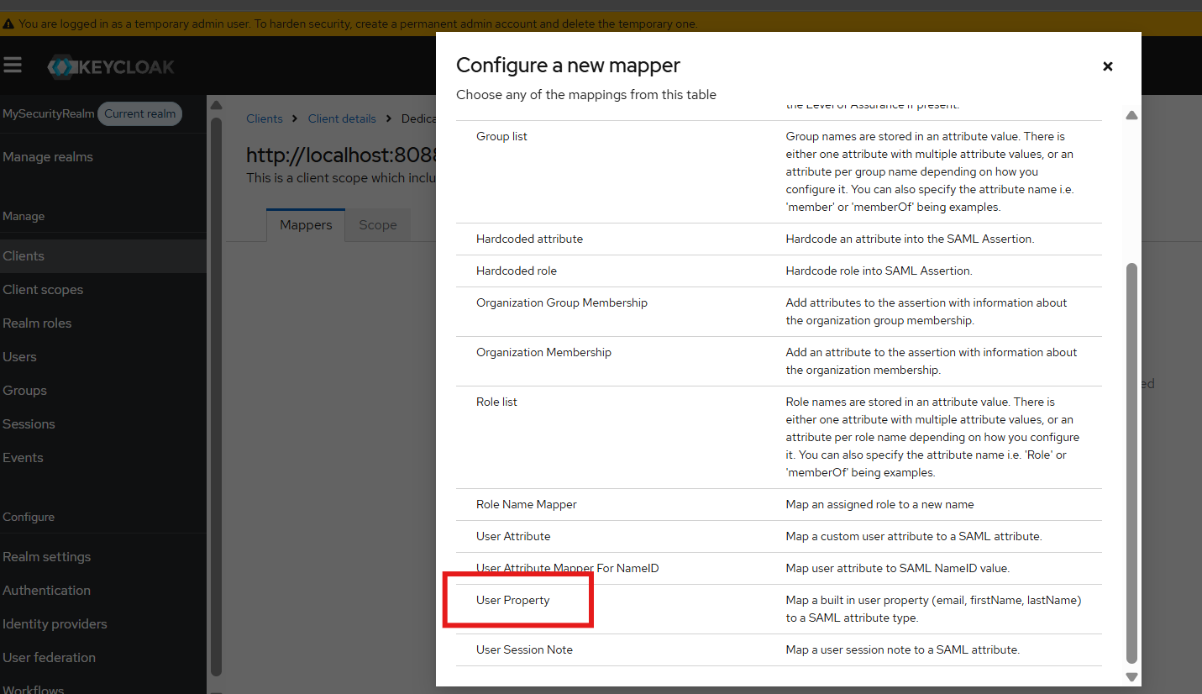

Fill the form using the following values:
Name: uid
Mapper Type: User Property
Property: username
Friendly Name: uid
SAML Attribute Name: uid
SAML Attribute NameFormat: Basic
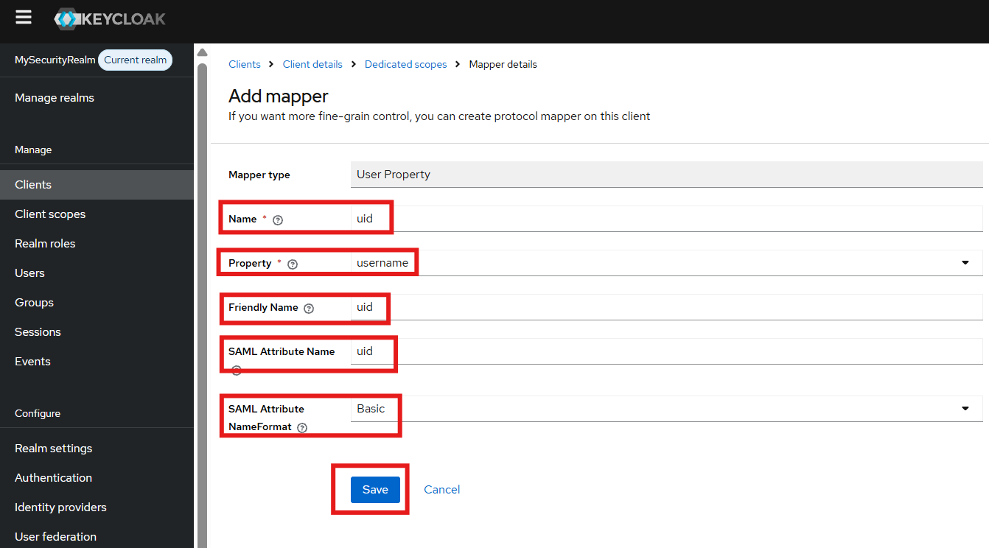
Keycloak therefore sends approximately:
<saml:Attribute
Name="uid"
NameFormat="urn:oasis:names:tc:SAML:2.0:attrname-format:basic">

12. Configure “uid” Mapper in Shibboleth
Modify: C:\Projects\Shibboleth_As_SP\shibboleth-sp\etc\shibboleth\attribute-map.xml
Add:
<Attribute
name="uid"
nameFormat="urn:oasis:names:tc:SAML:2.0:attrname-format:basic"
id="uid"/>

Important Note: Backup the original attribute-map.xml first.

13. Test Shibboleth
Restart Shibboleth (CMD with admin rights):
> sc stop shibd_default
> sc start shibd_default
Or Win + R, type services.msc. Then use the UI to stop and start shibd_default service:
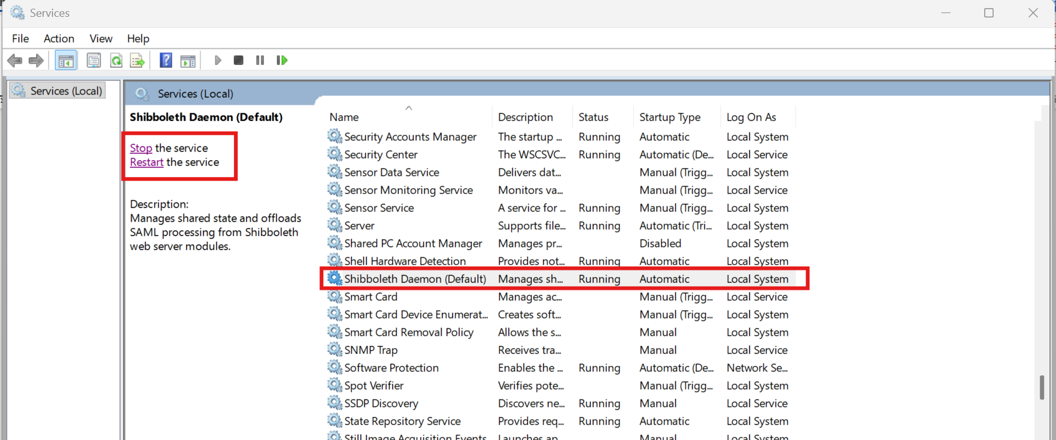

Restart IIS (CMD with admin rights):
> iisreset
Or Win + R, type inetmgr. Then use the UI to restart IIS server:
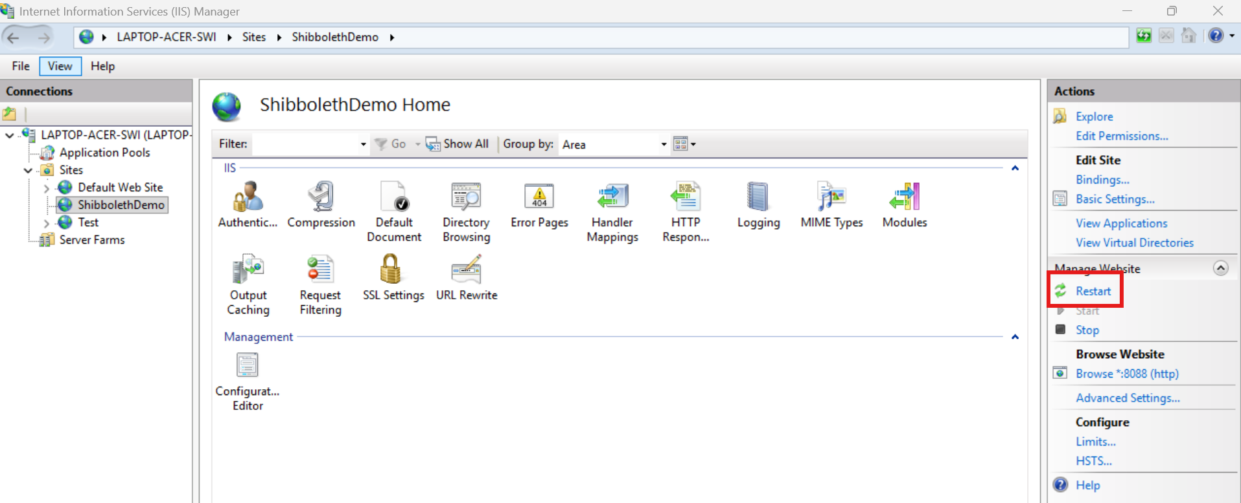

To test SAML type the following URL in a new Chrome Incognito browser:
http://localhost:8088/
login as yunpeng.li/password

To display session values, modify shibboleth2.xml:
<Handler type="Session" Location="/Session" showAttributeValues="true"/>
Then type the following URL in a new Chrome Incognito browser: http://localhost:8088/Shibboleth.sso/Session
It should display:
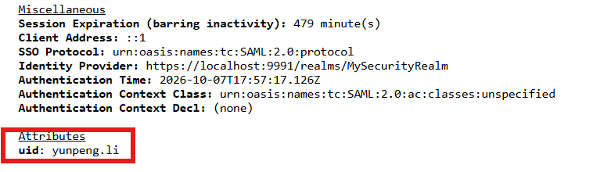

14. Enable ARR Reverse Proxy
Open IIS manager:
Win + R then type Inetmgr
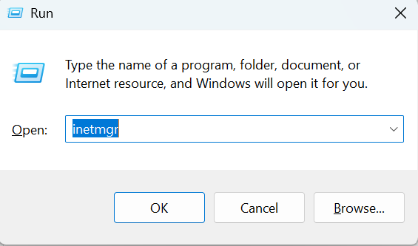

Click Application Request Routing Cache:
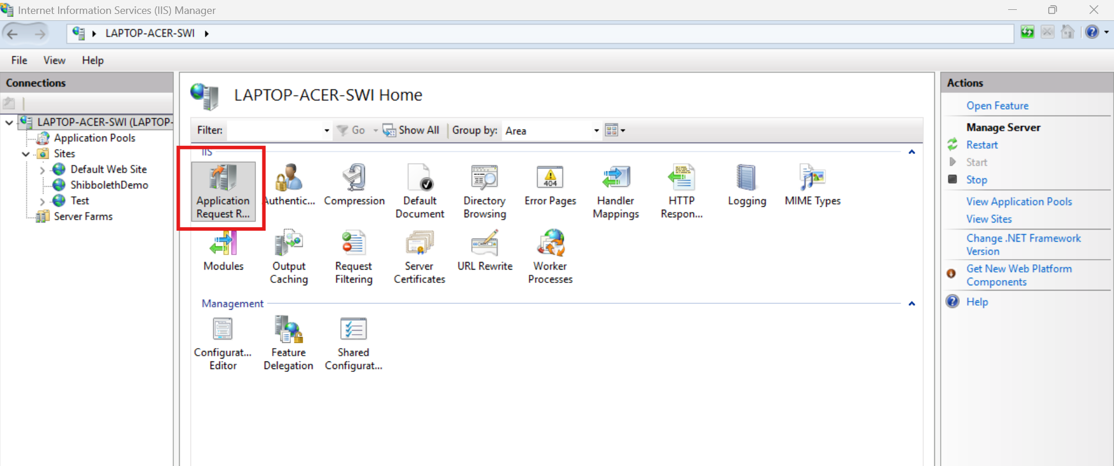

Click Server Proxy Settings:

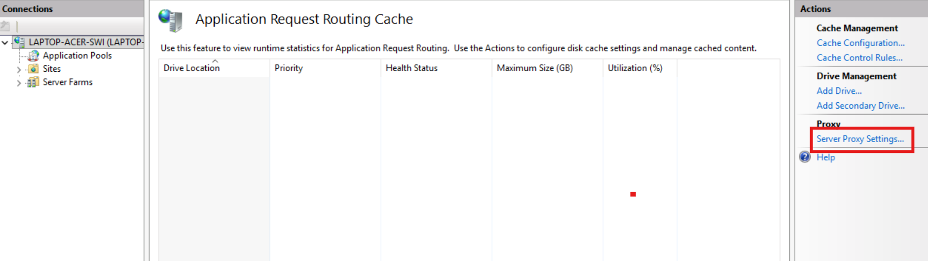

Check Enable proxy then click Apply:
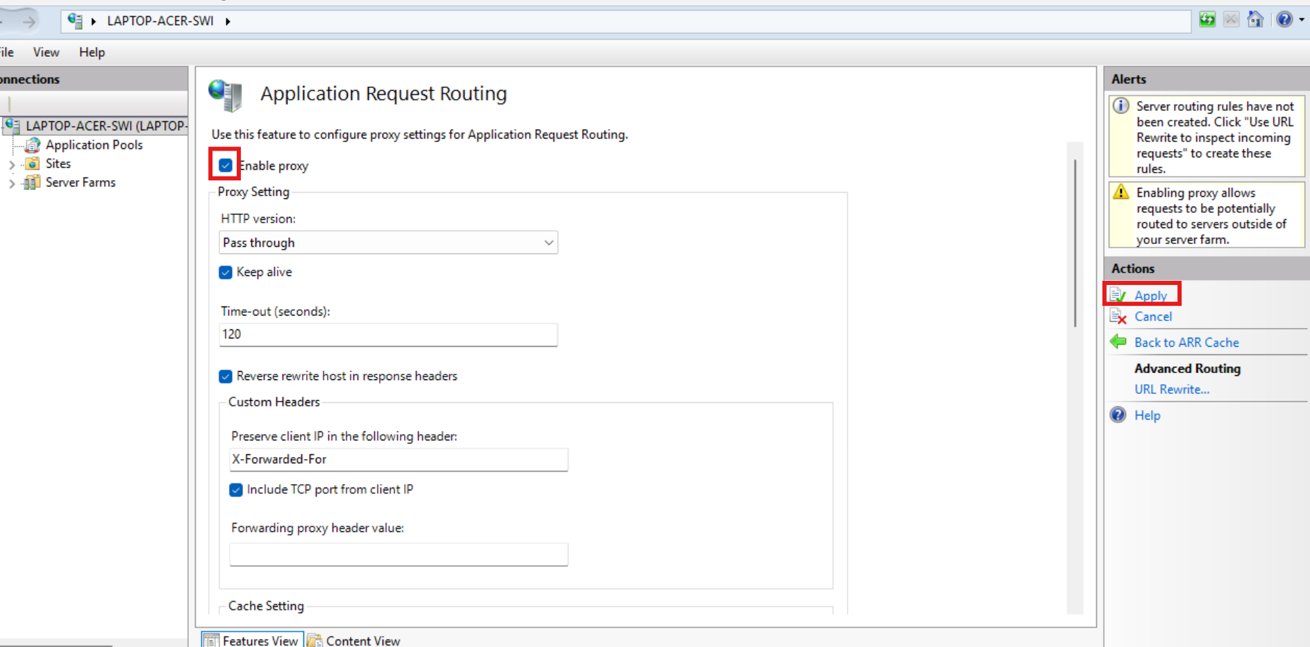

15. Create the IIS Reverse-proxy Rule
Select the site and click URL Rewrite:
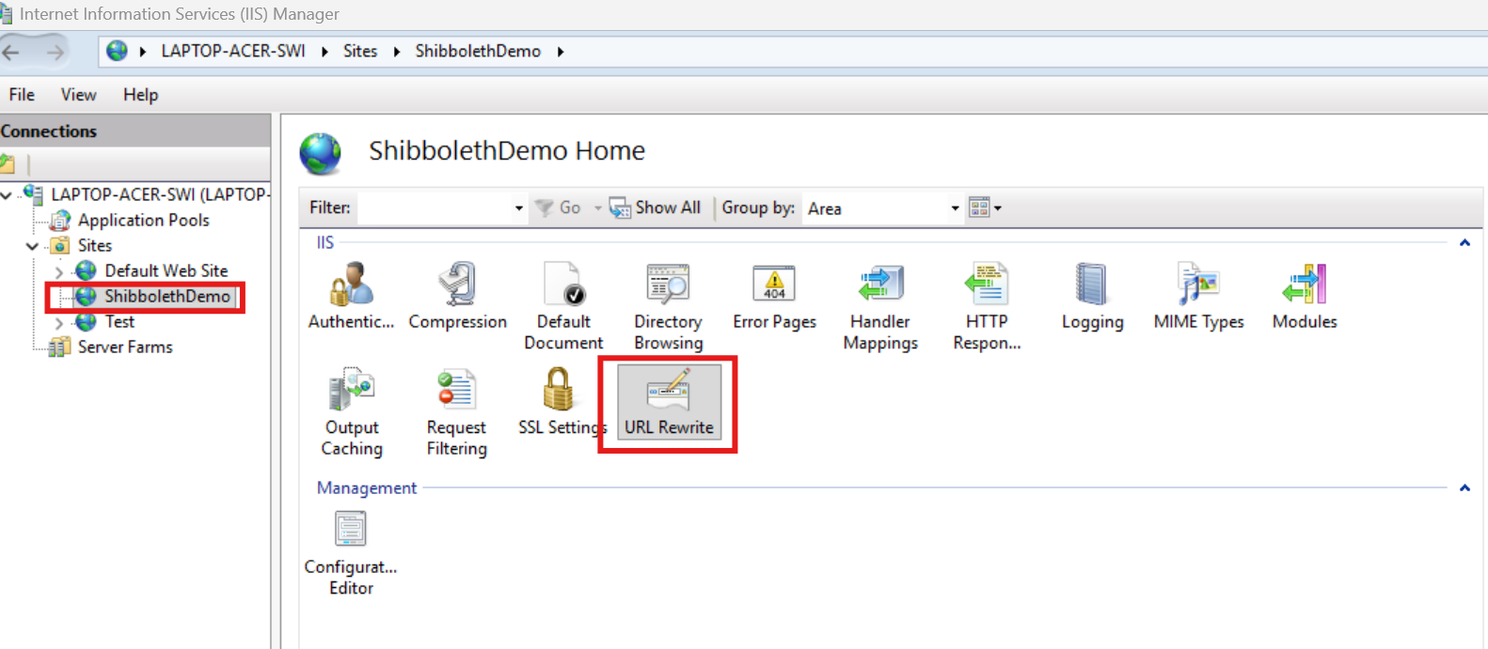

Create the reverse proxy rule by clicking Add Rule(s):

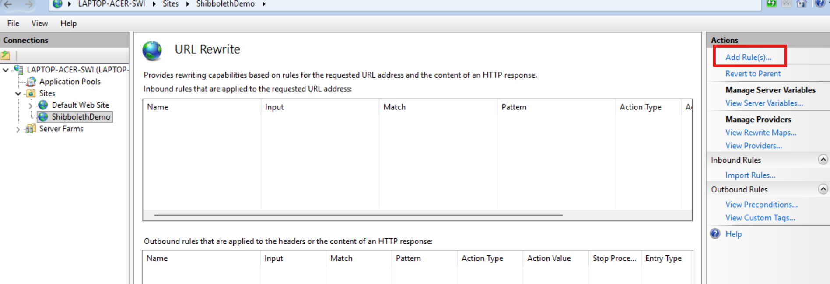

Click Blank rule then click OK:
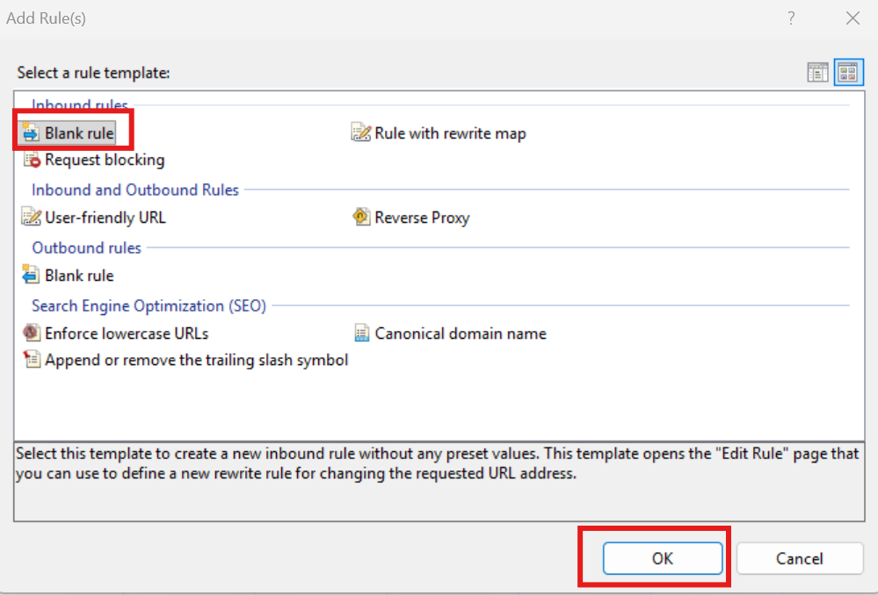
Name the rule as “Spring Boot Reverse Proxy” and specify other values:
Requested URL: Matches the Pattern
Using: Regular Expressions
Pattern: ^(.*)$
Then click Add to add a condition:
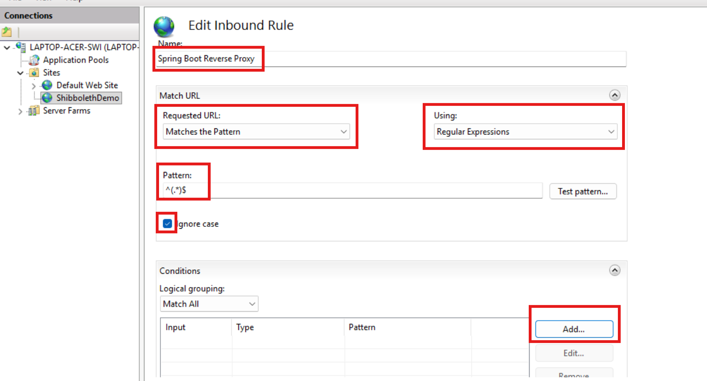

Specify the values:
Condition input: {URL}
Check: Does Not Match the Pattern
Pattern: ^/Shibboleth\.sso(?:/|$)
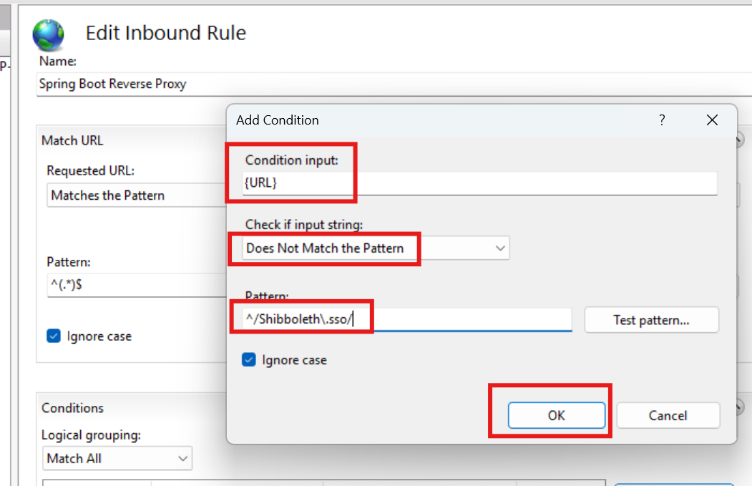

For the action section, specify the values:
Action type: Rewrite
Rewrite URL: http://127.0.0.1:9091/{R:1}
☑ Append query string
☑ Stop processing subsequent rules
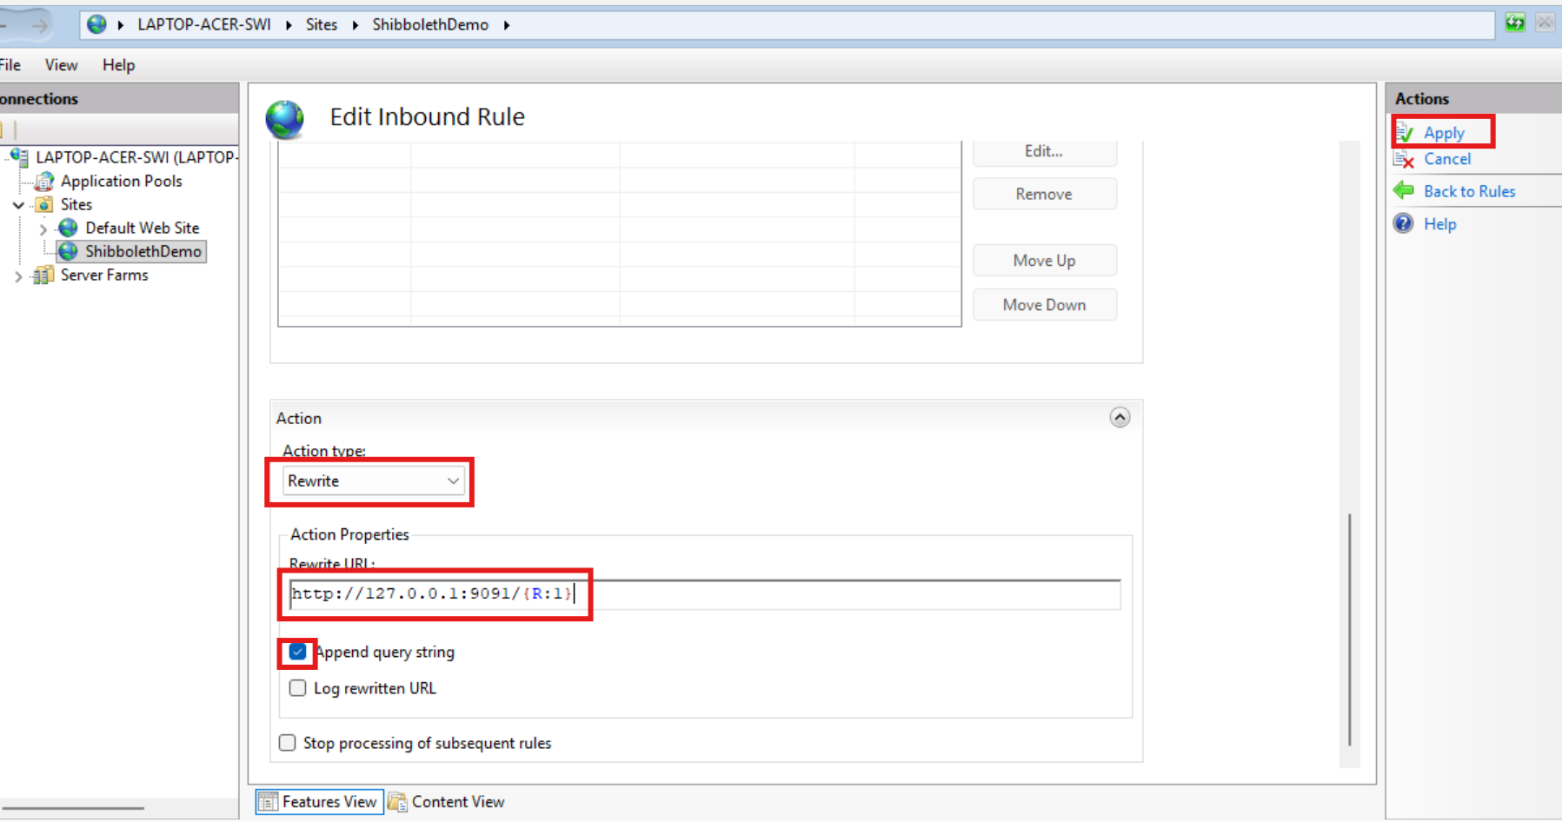

Note: In our IIS URL Rewrite configuration, the regular expression `^(.*)$` is used to match the entire application request path: `^` means the beginning of the string, `.` matches any character, `*` means zero or more occurrences, `( )` captures the matched value, and `$` means the end of the string; IIS stores that captured path as `{R:1}`, where `R` means Rule back-reference, so a request such as `/user` can be forwarded by ARR to `http://127.0.0.1:9091/user`. We also use the condition `^/Shibboleth\.sso(?:/|$)` to identify Shibboleth's own endpoints, such as `/Shibboleth.sso/Session`, `/Shibboleth.sso/Metadata`, and `/Shibboleth.sso/SAML2/POST`; here `\.` represents a literal period and `(?:/|$)` means either a `/` or the end of the URL. By configuring this condition as Does Not Match, IIS proxies normal application requests to Spring Boot while leaving `/Shibboleth.sso/*` requests for Shibboleth itself to process.

Restart IIS
> iisreset

16. Create a Regular Spring Boot Application
We can create a regular Spring Boot application (SpringBoot_No_SAML_App1) that does not process SAML directly. The application is not even aware of Shibboleth SP because the IIS handles the requests and delegates Shibboleth SP as the SAML service provider, which communicates with an IdP (Keycloak) for SAML SSO. The Spring application only cares about the “uid” HTTP Header attribute returned by SAML after a successful authentication.
We need to bind the Spring application to loopback only to improve security. See application.yml, and there is no additional Spring Security configuration:

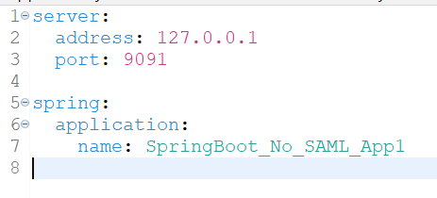
HomeController.java:
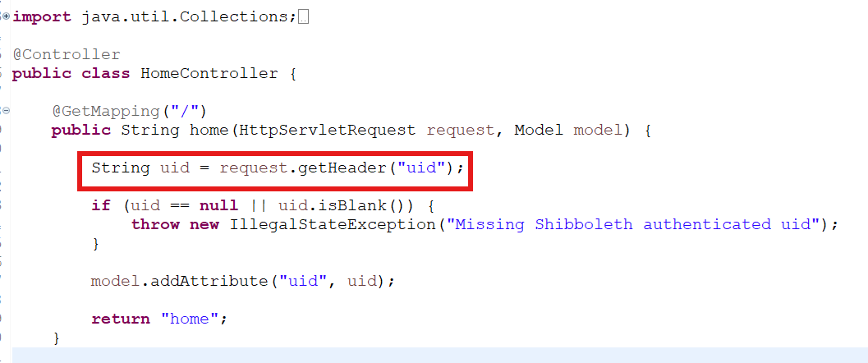

17. Demonstration
Start the regular Spring application by clicking start_spring_app_no_saml.bat. Type the following URL in a new Chrome Incognito browser:
http://localhost:8088/
It forwards SAML authentication request to the Keycloak login page:
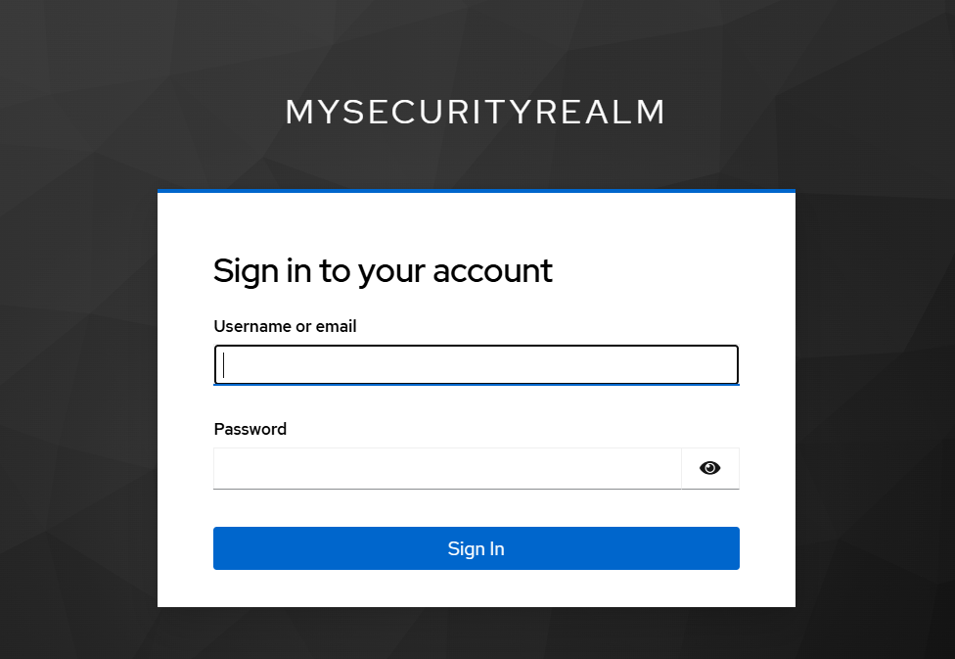
login as yunpeng.li/password
After successful authentication, the page displays the username (uid) information:
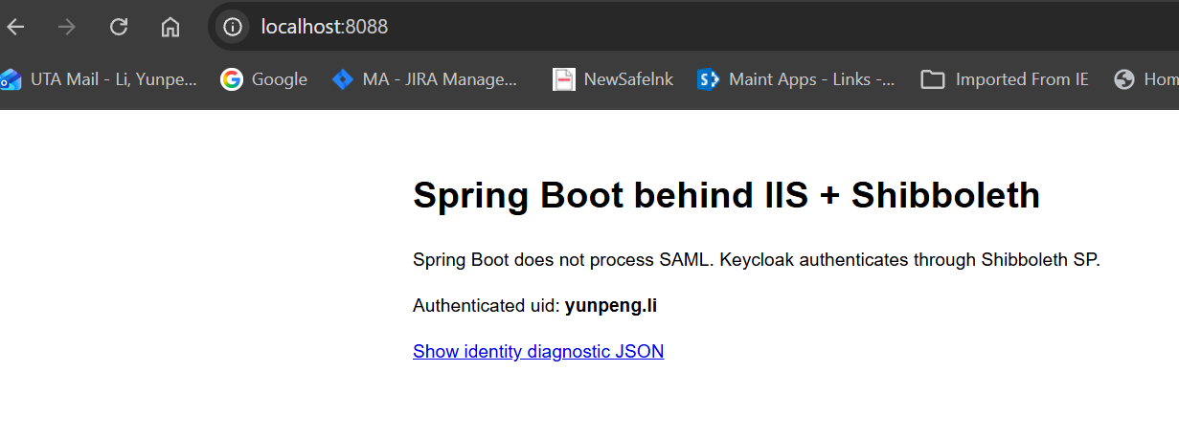
Click the “Show identity diagnostic JSON” link, it will show all the session attributes and values:
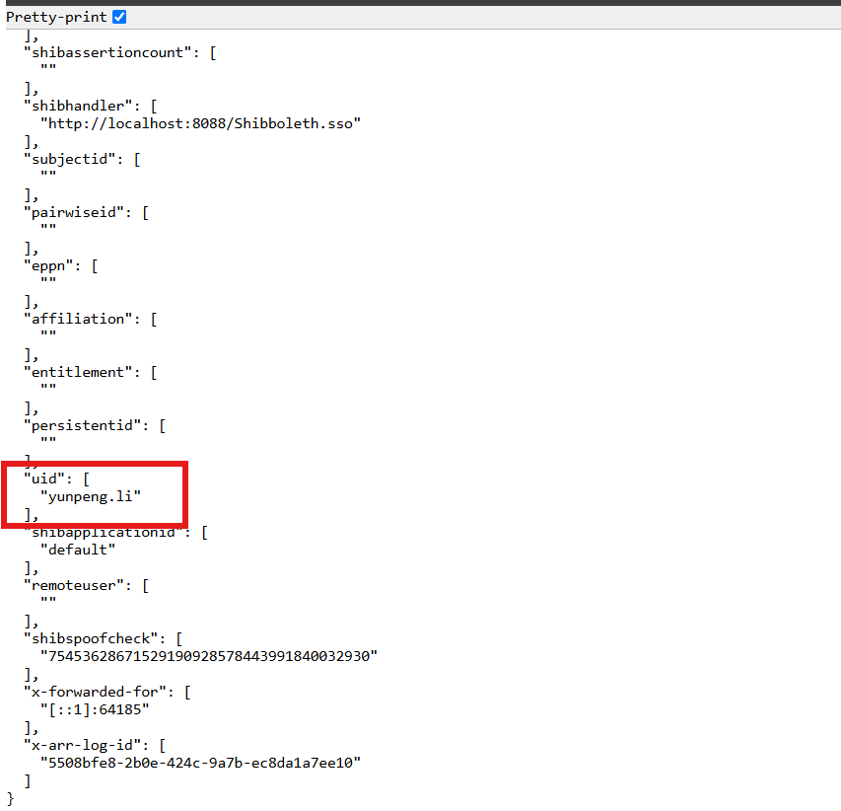
Start another Spring Boot application (SpringBoot_SAML_App) by clicking start_spring_app_saml.bat, which can process SAML authentication by itself and has a corresponding SP client (SpringBoot_SAML_App2) configured under the same security realm (MySecurityRealm) that client with entity ID http://localhost:8088/shibboleth resides.
Access the URL http://localhost:9092/ and it should pass SAML authentication and directly display the home page:
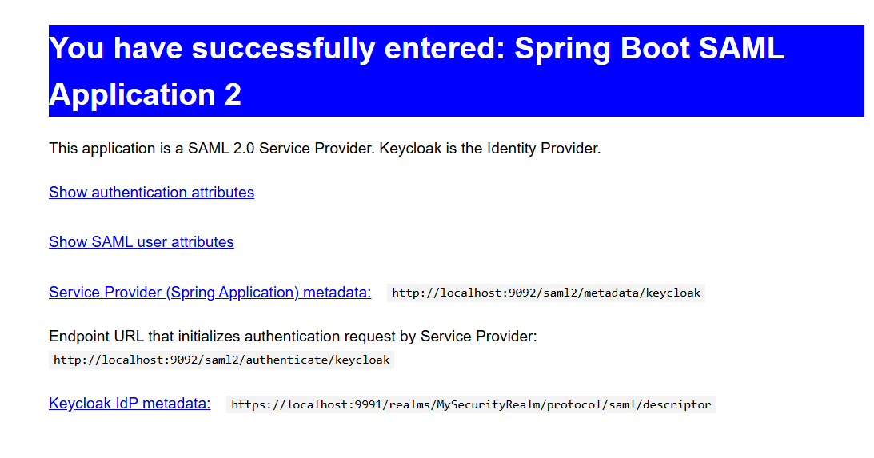
Access the Keycloak admin page through https://localhost:9991/ and display the user session in the MySecurityRealm. It shows user has accessed both application clients:
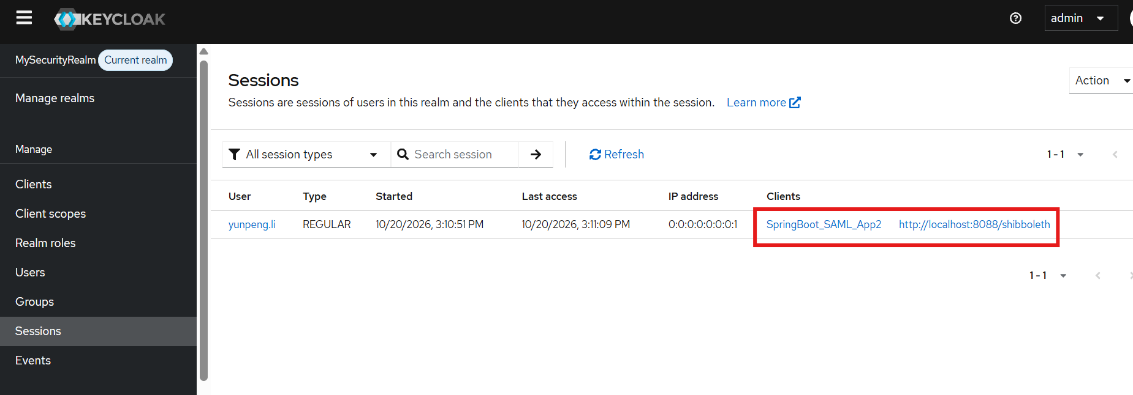

URLs
Keycloak admin:
https://localhost:9991/
login: admin/admin

Spring Application that does not process SAML by itself:
http://localhost:8088/
login: yunpeng.li/password

Spring Application that processes SAML by itself:
http://localhost:9092
login: yunpeng.li/password

18. Summary
Shibboleth SP can act as a SAML authentication layer in front of a web application that does not process SAML itself. In this architecture, Keycloak is the Identity Provider (IdP) that authenticates the user, while Shibboleth SP handles all SAML-related work, including redirecting the browser to Keycloak, sending the SAML authentication request, validating the SAML response, creating a local Shibboleth session, and extracting user attributes such as “uid”. The authenticated identity is then passed through IIS/ARR to the backend Spring Boot application, which simply reads the trusted user information (for example, “uid = yunpeng.li”) without needing any SAML libraries or configuration. In short, Keycloak authenticates the user, Shibboleth handles SAML and protects the application, ARR reverse-proxies the authenticated request, and Spring Boot focuses only on application logic and authorization.

